## **Definition of SDLC**

SDLC or the Software Development Life Cycle is a process that produces software with the highest quality and lowest cost in the shortest time. SDLC includes a detailed plan for how to develop, alter, maintain, and replace a software system.

SDLC involves several distinct stages, including planning, design, building, testing, and deployment. Popular SDLC models include the [waterfall model](http://learnaccessvba.com/application_development/waterfall_method.htm), [spiral model](http://searchsoftwarequality.techtarget.com/definition/spiral-model), and [Agile model](http://istqbexamcertification.com/what-is-agile-model-advantages-disadvantages-and-when-to-use-it/).

## **How SDLC Works**

SDLC works by lowering the cost of software development while simultaneously improving quality and shortening production time. SDLC achieves these apparently divergent goals by following a plan that removes the typical pitfalls to software development projects. That plan starts by evaluating existing systems for deficiencies. Next, it defines the requirements of the new system. It then creates the software through the stages of design, development, testing, and deployment. By anticipating costly mistakes like failing to ask the end user for suggestions, SLDC can eliminate redundant rework and after-the-fact fixes.

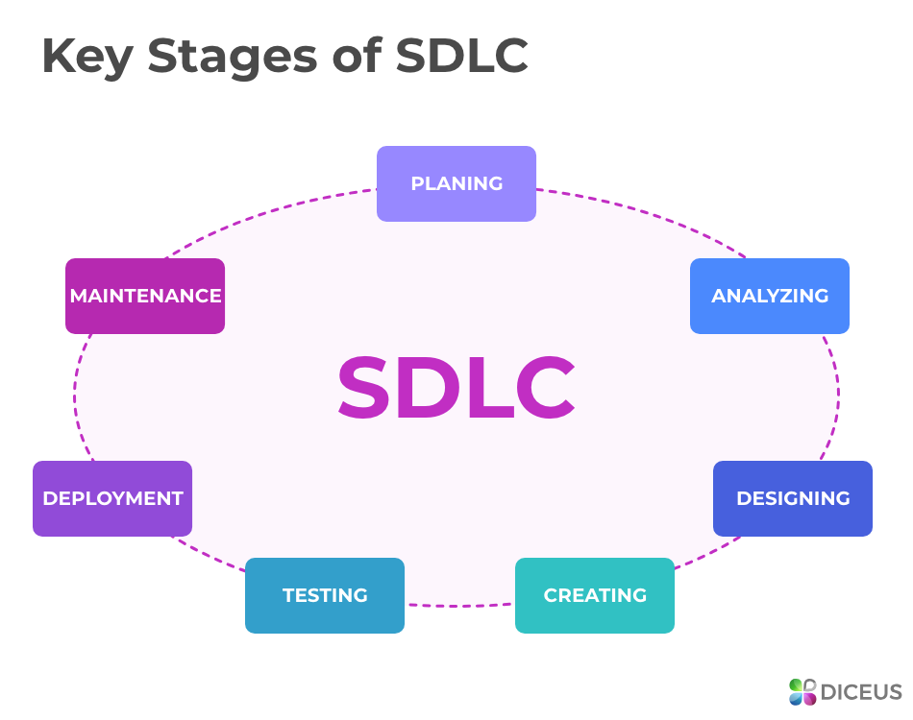

## **Stages and Best Practices of SDLC**

Following the best practices and/or stages of SDLC ensures the process works in a smooth, efficient, and productive way.

1. **Identify the**[**current problems**](https://stackify.com/sdlc-phases-identify-problems/)**.**“What don’t we want?” This stage of SDLC means getting input from all stakeholders, including customers, salespeople, industry experts, and programmers. Learn the strengths and weaknesses of the current system with improvement as the goal.
2. **Plan.** “What do we want?” In this stage of SDLC, the team defines the requirements of the new software and determines the cost and resources required. It also details the risks involved and provides sub-plans for softening those risks. In this stage, a Software Requirement Specification document is created.
3. **Design.** “How will we get what we want?” This phase of SDLC starts by turning the software specifications into a design plan called the Design Specification. All stakeholders then review this plan and offer feedback and suggestions. It’s crucial to have a plan for collecting and incorporating stakeholder input into this document. Failure at this stage will almost certainly result in cost overruns at best and total collapse of the project at worst.
4. **Build.** “Let’s create what we want.” This SDLC stage develops the software by generating all the actual code. If the previous steps have been followed with attention to detail, this is actually the least complicated step.
5. **Test.** “Did we get what we want?” In this stage, we test for defects and deficiencies. We fix those issues until the product meets the original specifications.
6. **Deploy.** “Let’s start using what we got.” Often, this part of the SDLC process happens in a limited way at first. Depending on feedback from end users, more adjustments can be made.
7. **Maintain.** “Let’s get this closer to what we want.” The plan almost never turns out perfect when it meets reality. Further, as conditions in the real world change, we need to update and advance the software to match.

## Benefits of SDLC

SDLC done right can allow the highest level of management control and documentation. Developers understand what they should build and why. All parties agree on the goal up front and see a clear plan for arriving at that goal. Everyone understands the costs and resources required.

Several pitfalls can turn an SDLC implementation into more of a roadblock to development than a tool that helps us. Failure to take into account the needs of customers and all users and stakeholders can result in a poor understanding of the system requirements at the outset. The benefits of SDLC only exist if the plan is followed faithfully.